- Launch one EC2 using Amazon Linux 2 image and add a script in user data to install Apache:
Step 1
Login to AWS Console.
Go to
EC2 → Launch Instance
Step 2
Configure:
- Name: AmazonLinux-Apache
- AMI: Amazon Linux 2
- Instance Type: t2.micro
- Key Pair: Select your key
- Security Group
  - SSH (22)
  - HTTP (80)
Step 3
Paste this into User Data
#!/bin/bash

yum update -y
yum install httpd -y
systemctl start httpd
systemctl enable httpd

echo "<h1>Apache Installed Successfully</h1>" > /var/www/html/index.html
Step 4
Launch Instance.
Verify
Open
http://40.192.24.2
Expected output
Apache Installed Successfully

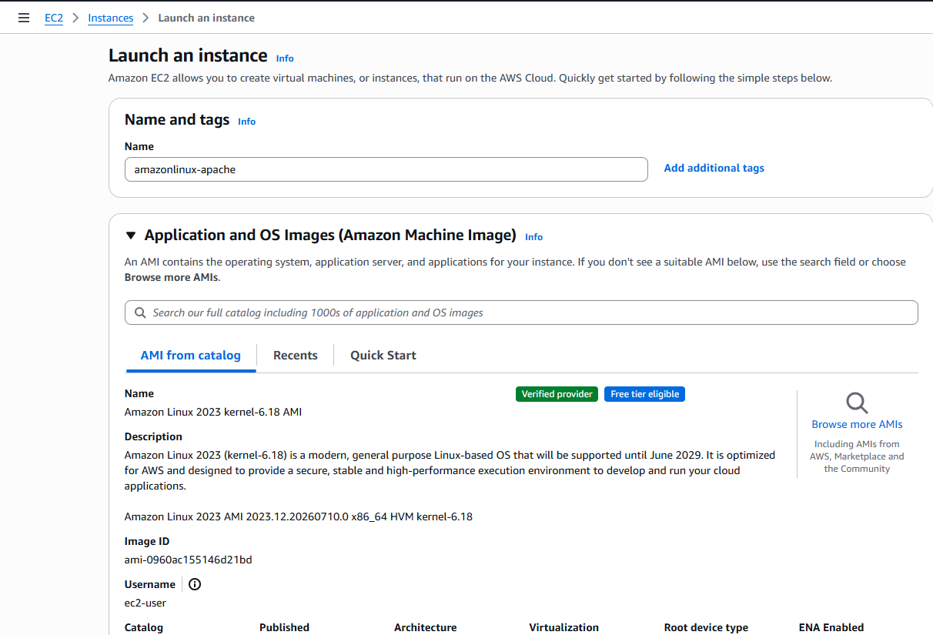

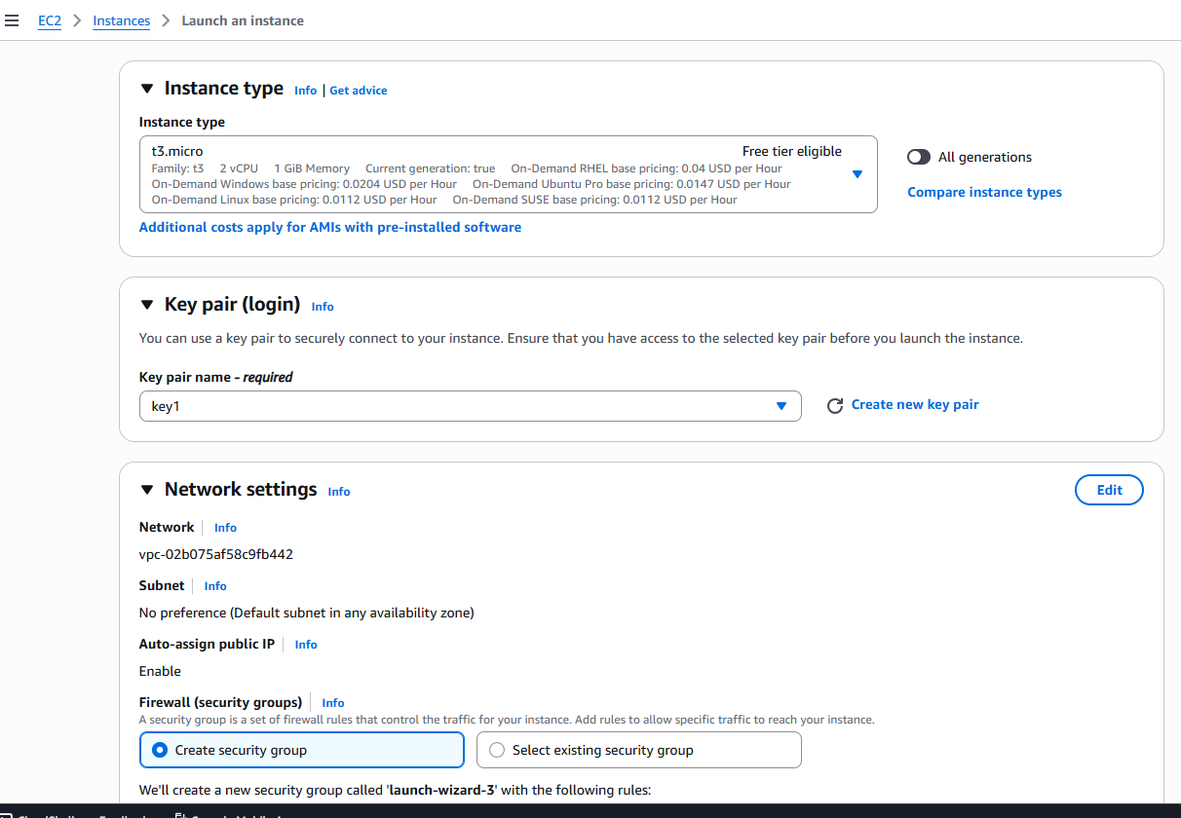

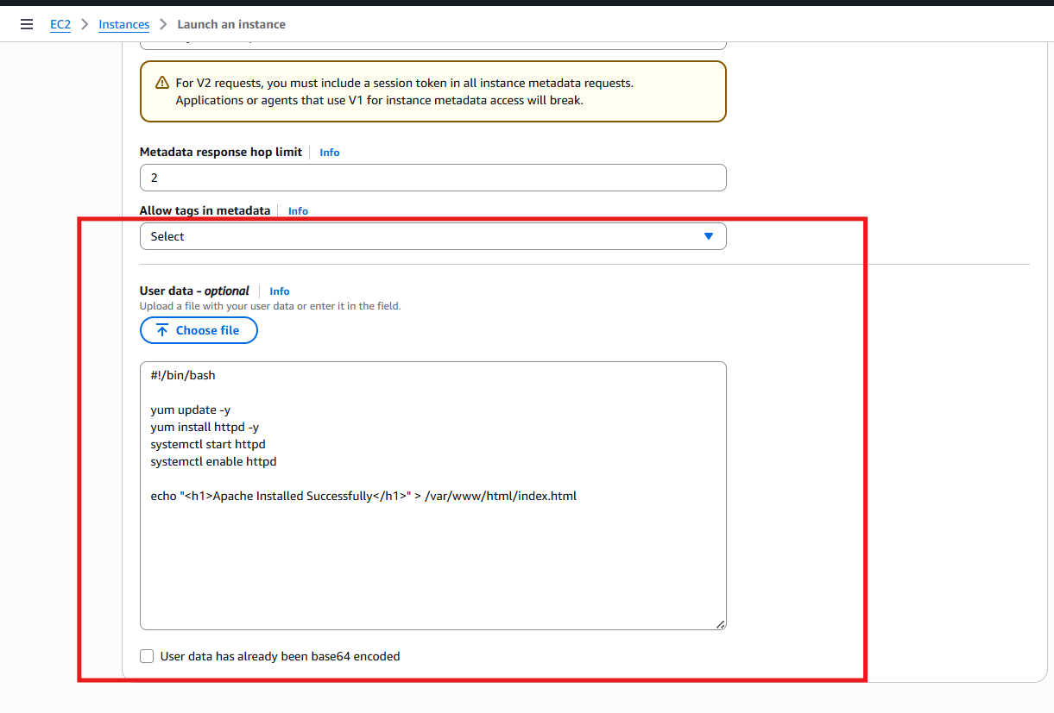

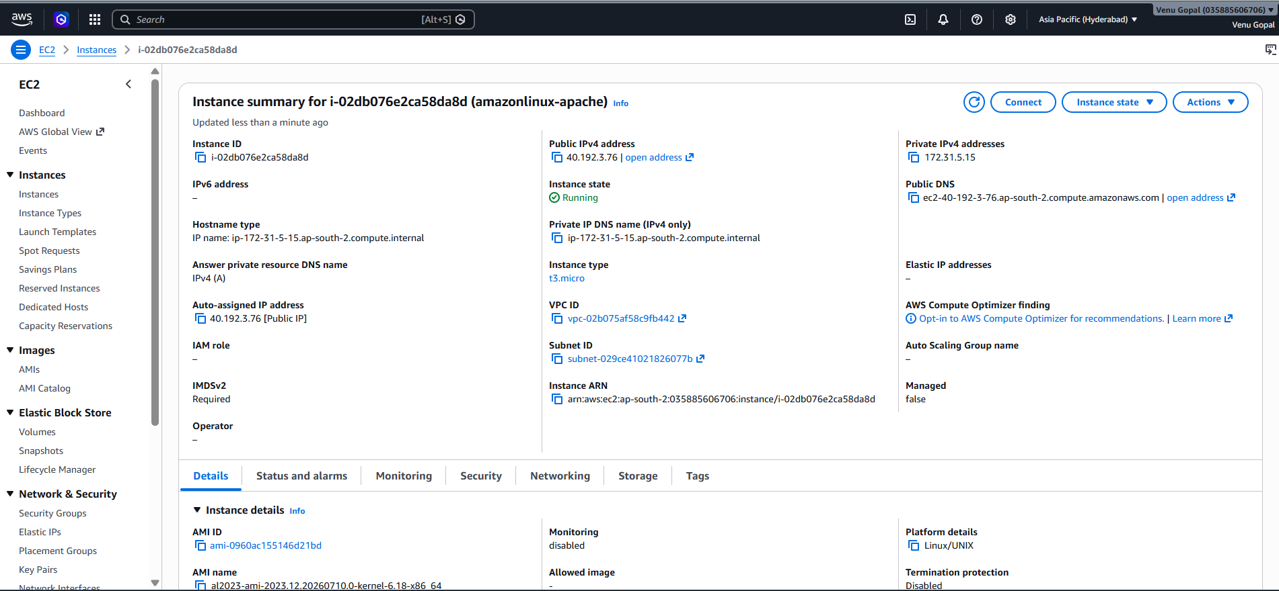

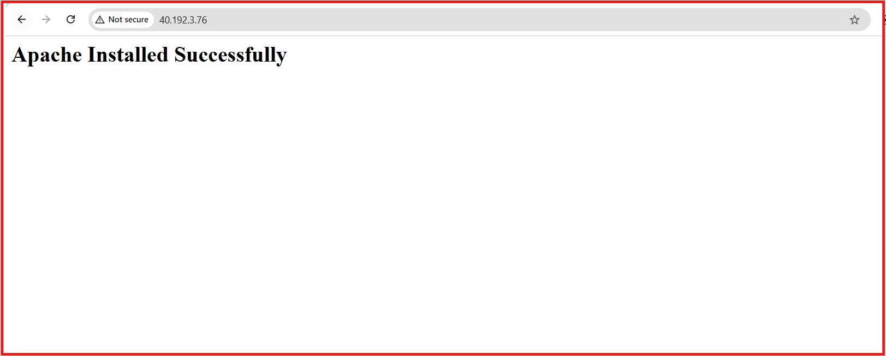

- Launch one EC2 using Ubuntu image and add a script in user data to install Nginx.
Launch another EC2.
Configuration
- Ubuntu 24.04 LTS (or available Ubuntu)
- t2.micro
- Allow
  - SSH
  - HTTP
User Data
#!/bin/bash

apt update -y
apt install nginx -y
systemctl start nginx
systemctl enable nginx

echo "<h1>Nginx Installed Successfully</h1>" | tee /var/www/html/index.html
Launch.
Open
http://16.112.159.65
You should see
Nginx Installed Successfully

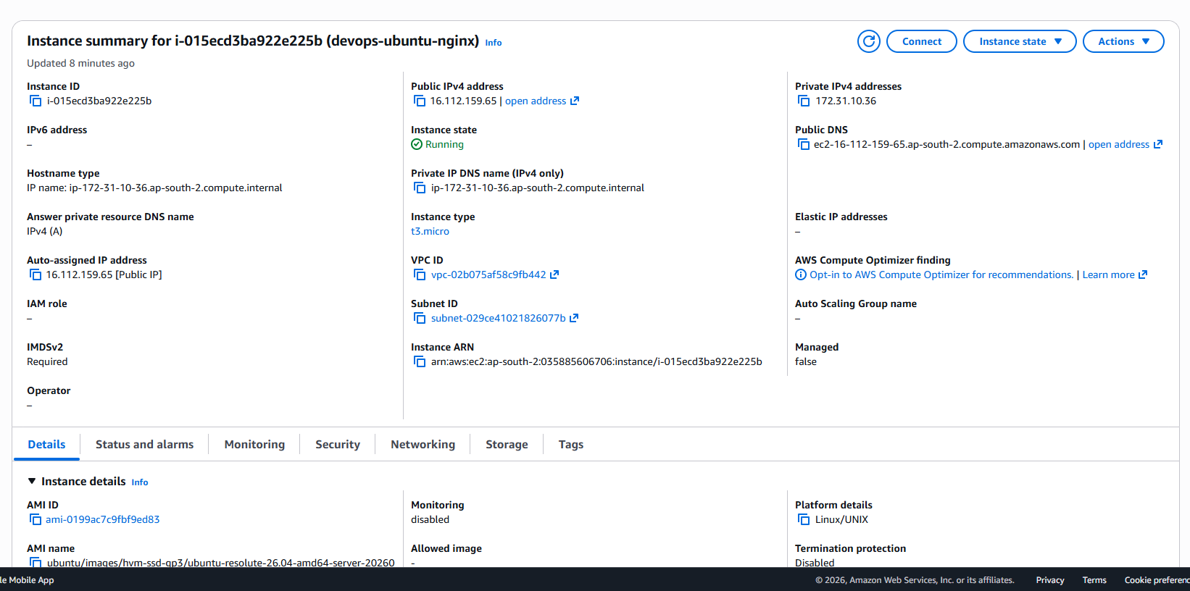

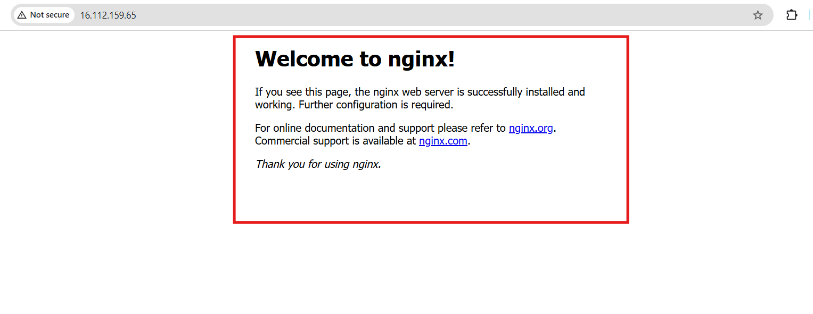
- Launch one Windows server and install Tomcat on Windows.
Launch
- Windows Server 2022
- t2.medium (recommended)
- Allow RDP (3389)
Connect
Download Password
Decrypt password using your key pair.
Connect using Remote Desktop.

Install Java
Download JDK
Example:
Oracle JDK 21
or
Amazon Corretto 21
Install it.
Verify
Open CMD
java -version

Download Tomcat
Download
Tomcat ZIP
Example
apache-tomcat-10.x.zip
Extract to
C:\Tomcat

Start Tomcat
Go to
C:\Tomcat\bin
Double-click
startup.bat
or
startup.bat
Visit
http://localhost:8080
or
http://18.60.146.252:8080
Make sure Security Group allows
TCP 8080
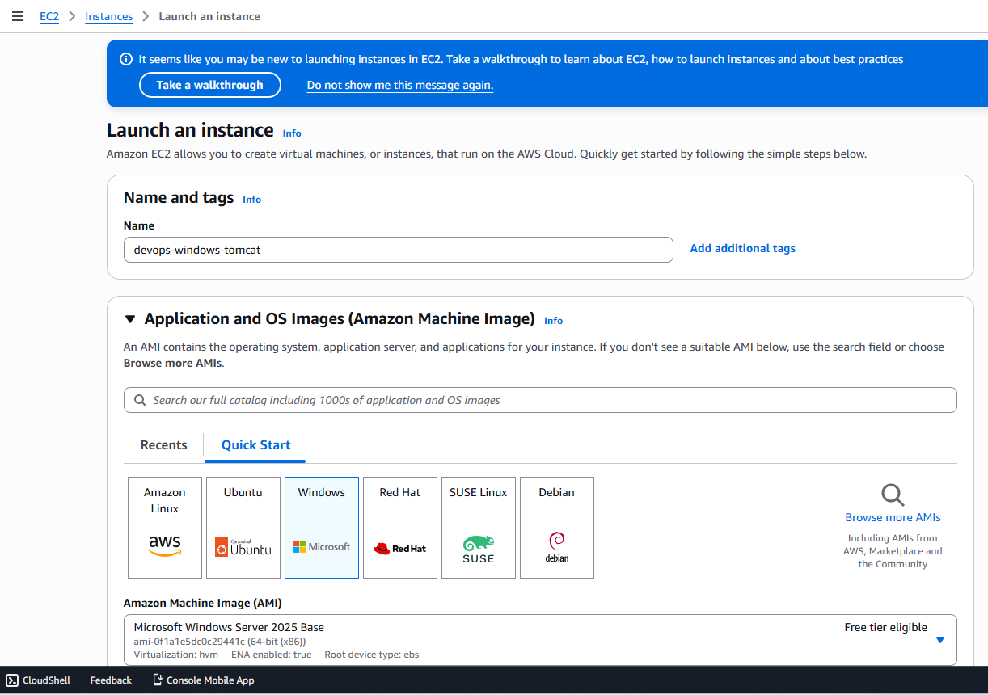

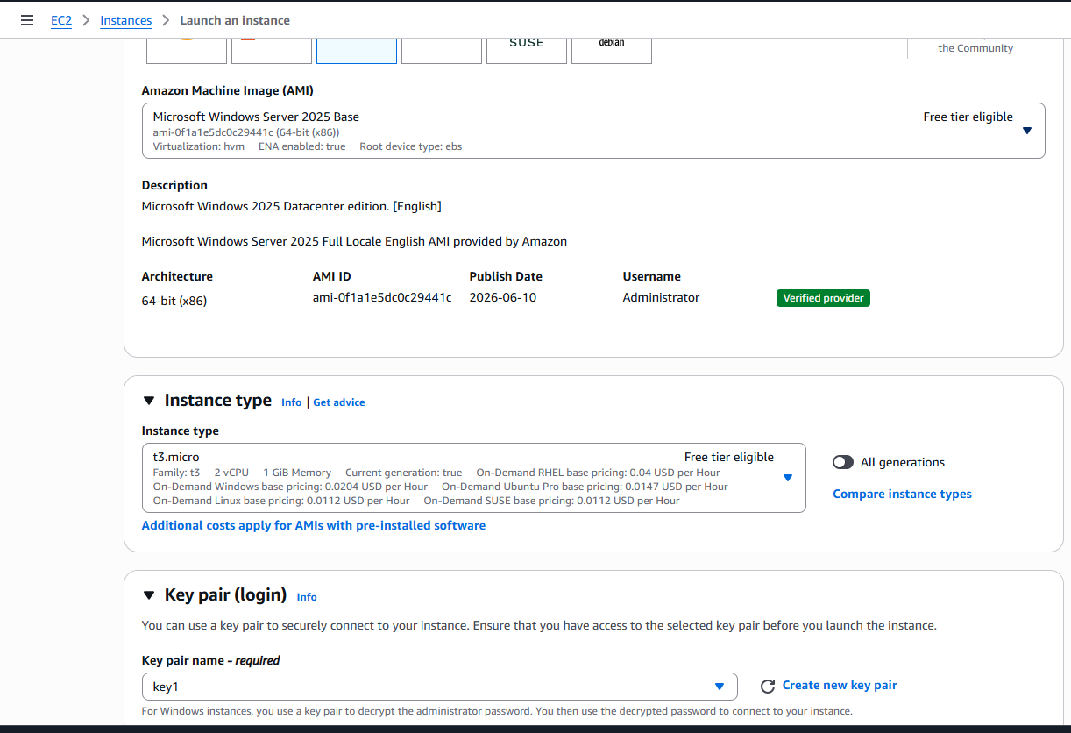

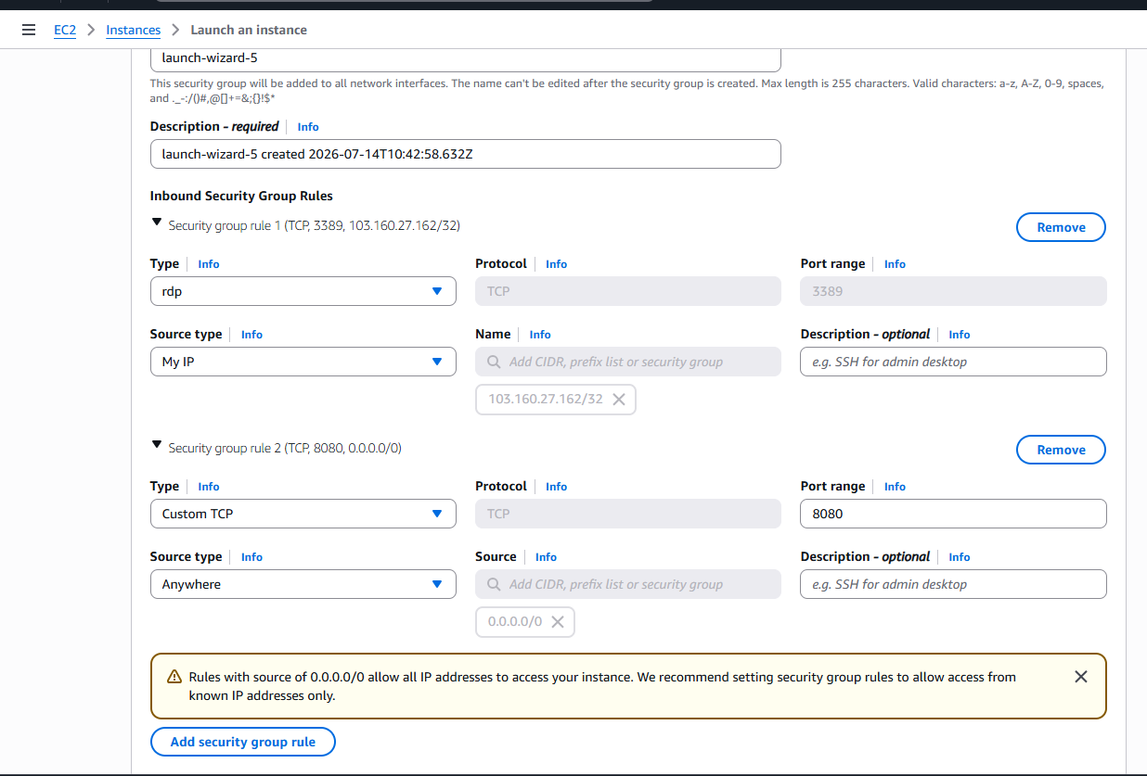

Connect to Windows Server:

Steps
- Click Upload private key file.
- Select your key1.pem file from your computer.
  - This is the same file you downloaded when you created the key pair.
- AWS will automatically decrypt the Windows Administrator password.
- You'll then see:
  - Username: Administrator
  - Password: (generated password)
After that:
- Click Download Remote Desktop File.
- Open the .rdp file.
- Log in with:
  - Username: Administrator
  - Password: the decrypted password.

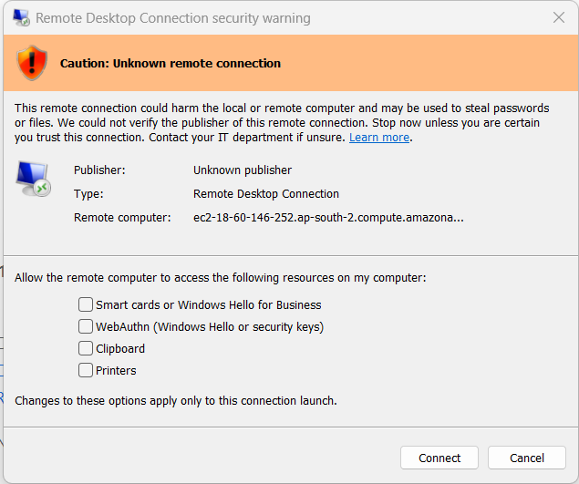
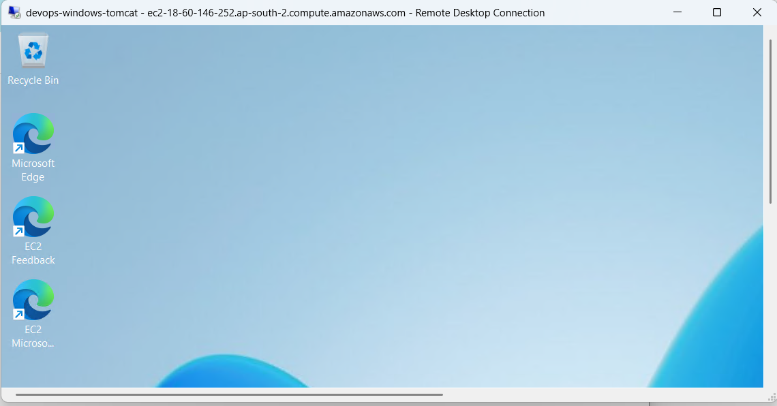

Download Java
Open Microsoft Edge.
Download OpenJDK 24 (or Amazon Corretto 21).
Example:
https://jdk.java.net/
Download the Windows x64 Installer (.msi) if available.

Install Java
Run the downloaded installer.
Click:
Next
Next
Install
Finish

Verify Java
Open Command Prompt.
Run:
java -version
Expected:
openjdk version "24.0.2"
Run:
javac -version
Expected:
javac 24.0.2
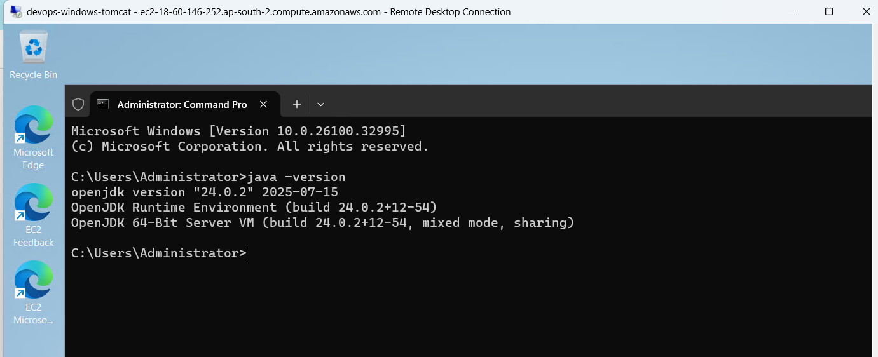

Extract Tomcat
Extract to:
C:\Apache\Tomcat11
Recommended: Avoid extracting to C:\Program Files or C:\Program Files (x86) because Windows may restrict permissions there.
The folder should look like:
C:\Apache\Tomcat11\
bin
conf
lib
logs
temp
webapps
work

Configure JAVA_HOME (only if using the ZIP version of Java)
If you installed Java with an installer, you can usually skip this step.
Otherwise:
Open:
This PC
→ Properties
→ Advanced System Settings
→ Environment Variables
Create a new System Variable:
JAVA_HOME
Value:
C:\Program Files\Java\jdk-24
(or wherever your JDK is installed)
Edit the Path variable.
Add:
%JAVA_HOME%\bin
Click OK.

Verify JAVA_HOME
Open a new Command Prompt.
Run:
echo %JAVA_HOME%
Expected output:
C:\Program Files\Java\jdk-24

Start Tomcat
Open:
C:\Apache\Tomcat11\bin
Double-click:
startup.bat
or run:
startup.bat
A new Command Prompt window should open and remain running.

Verify Tomcat
Run:
netstat -ano | findstr :8080
Expected:
TCP 0.0.0.0:8080 LISTENING

Open Tomcat
Inside the Windows Server:
http://localhost:8080
From your local computer:
http://<Public-IP>:8080

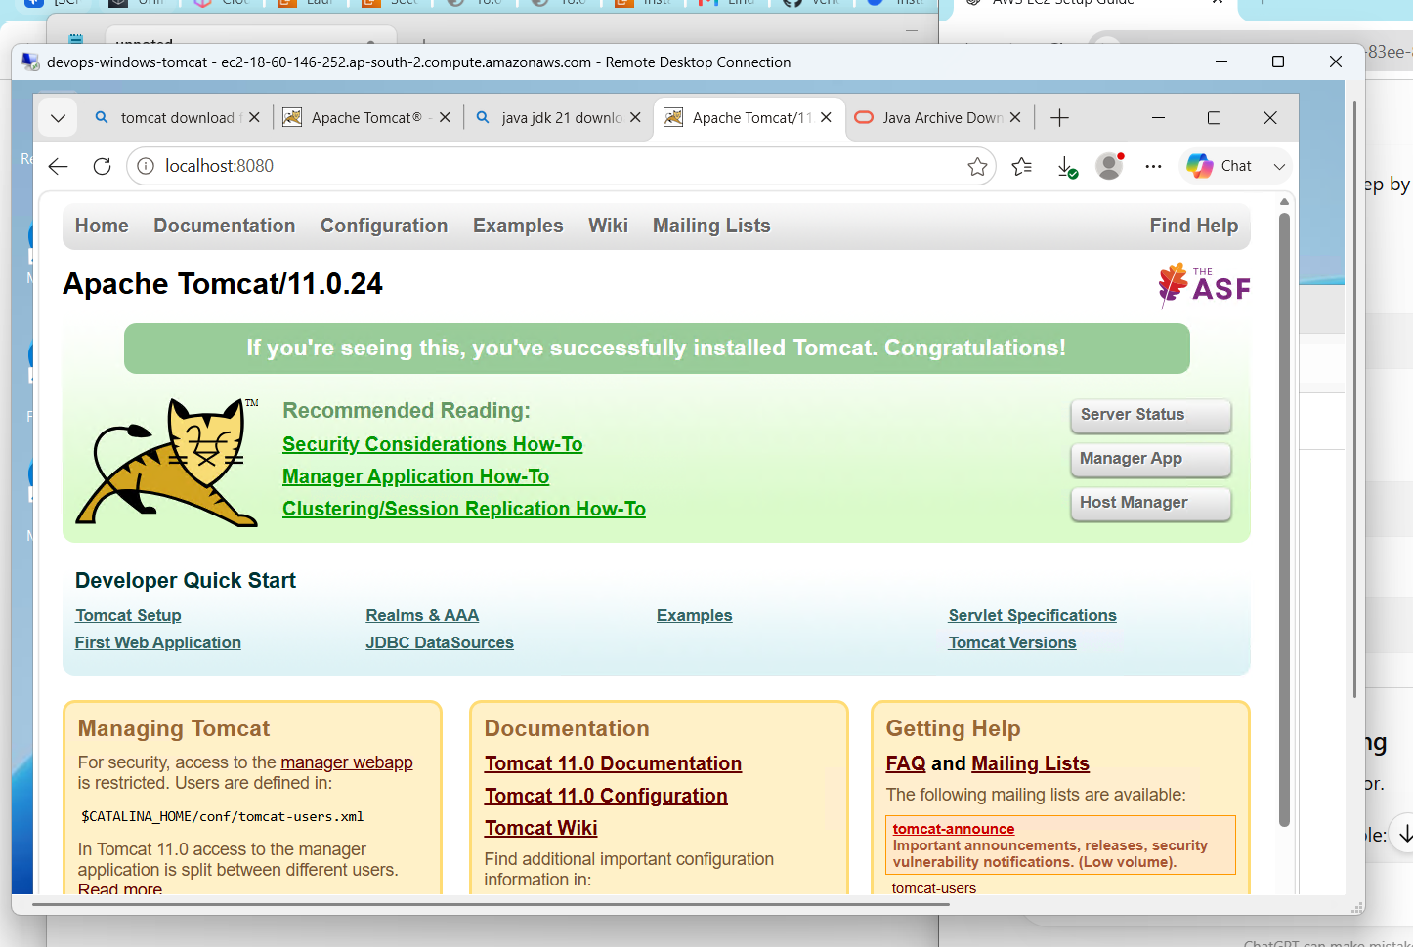

- Take a snapshot of the instance created in Task 1.
What is a Snapshot?
An EBS Snapshot is a backup of an EC2 instance's EBS volume. It is stored in Amazon S3 and can later be used to restore the volume or create a new volume.

Step 1: Go to EC2 Dashboard
- Log in to the AWS Management Console.
- Navigate to EC2.
- In the left navigation pane, click Instances.

Step 2: Select the Amazon Linux Instance
Select the instance you created in Task 1 (for example, amazonlinux-apache).

Step 3: Open the Storage Tab
- Scroll down to the instance details.
- Click the Storage tab.
- Under Block devices, you'll see the attached Volume ID (for example, vol-xxxxxxxxxxxxxxxxx).
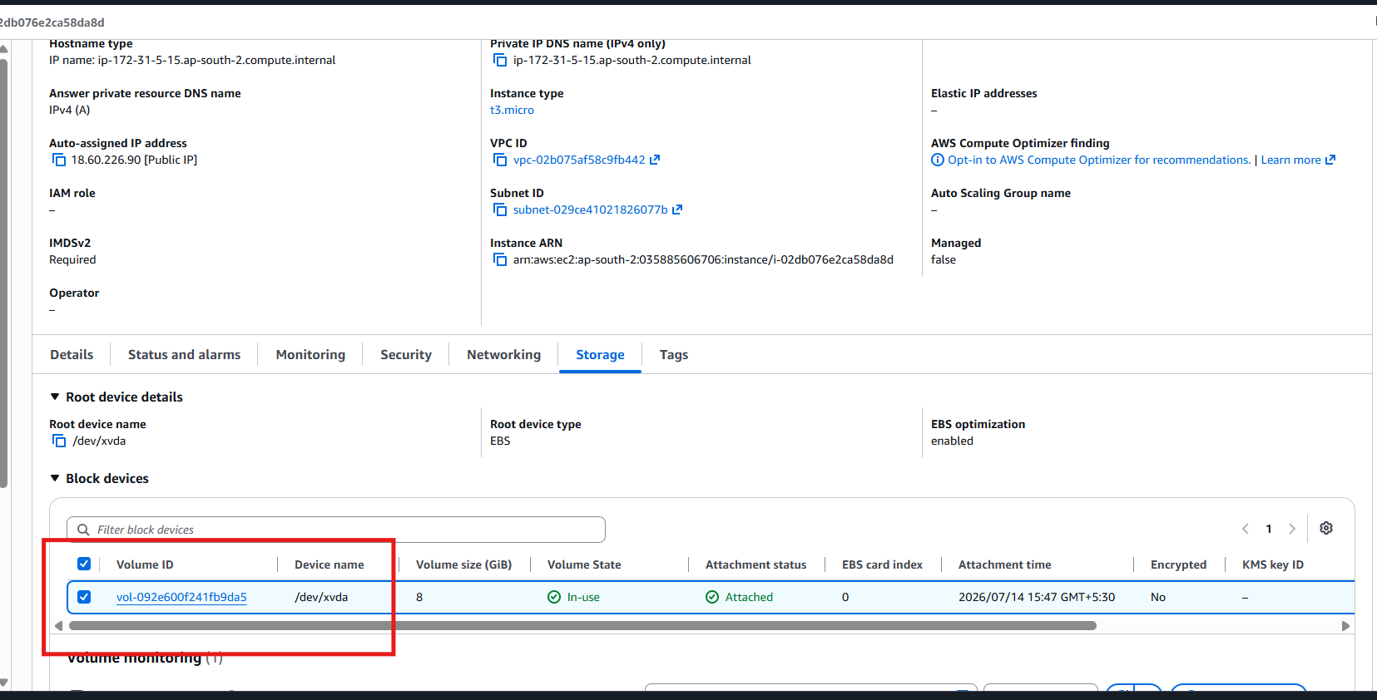

Step 4: Open the Volume
Click the Volume ID.
This takes you to the Elastic Block Store (EBS) → Volumes page.

Step 5: Create the Snapshot
- Select the volume.
- Click Actions.
- Select Create Snapshot.
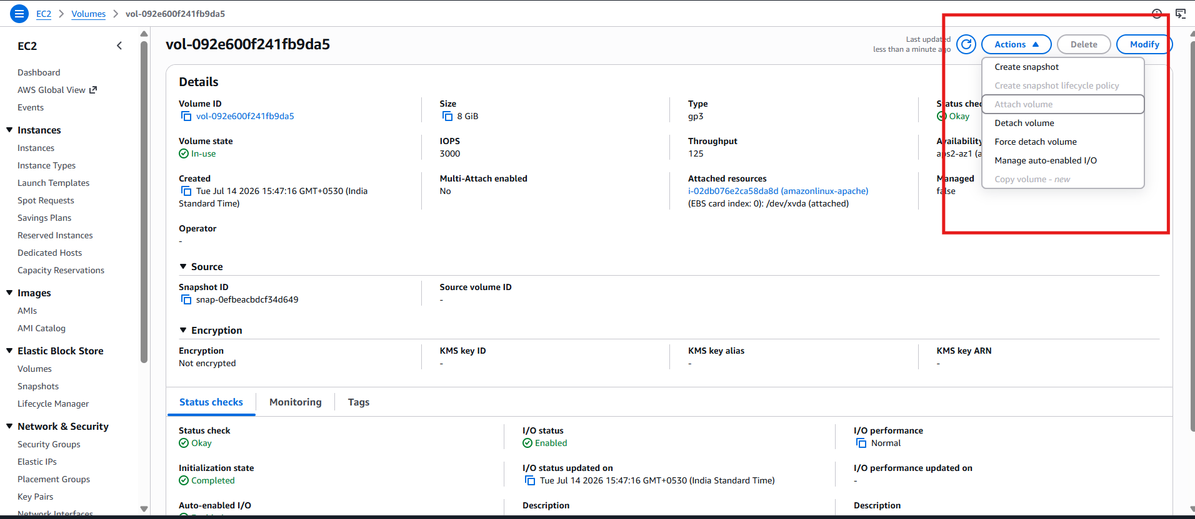

Step 6: Enter Snapshot Details
Fill in:
Description
Snapshot of Amazon Linux Apache Server
(Optional) Add a Name tag:
apache-snapshot
Then click:
Create Snapshot
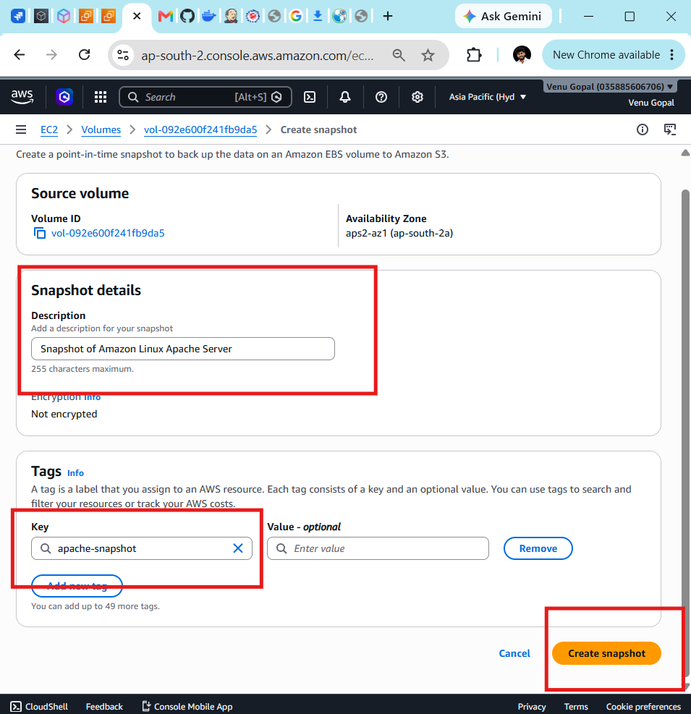

Step 7: Verify the Snapshot
- In the left navigation pane, click:
Snapshots
- You'll see your snapshot.
Initially, its state will be:
Pending
After a few minutes, it changes to:
Completed
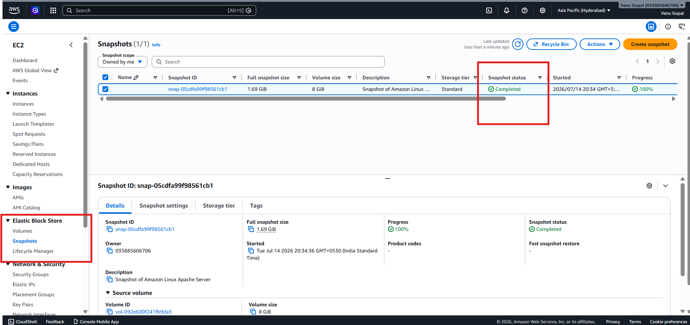
Architecture
Amazon Linux EC2
│
▼
EBS Volume
│
▼
Create Snapshot
│
▼
Amazon EBS Snapshot

- Assign passwordless authentication for the EC2 created in Task 2.
Configure SSH key-based authentication so you can log in to the Ubuntu EC2 instance without entering a password.
Note: EC2 instances already use SSH keys by default, so you don't normally enter a password. This exercise demonstrates how to create your own SSH key pair and use it for authentication between machines.

Scenario
Assume:
- Server: Ubuntu EC2 (Task 2)
- Client: Your local computer (Git Bash/PowerShell)
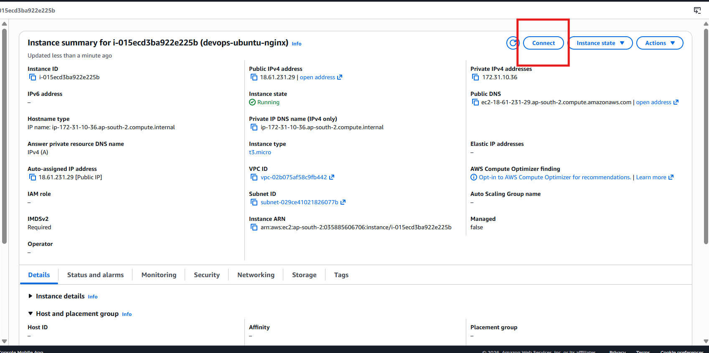

Step 1: Connect to Ubuntu EC2
From Git Bash:
ssh -i key1.pem ubuntu@<Public-IP>
Example:
ssh -i key1.pem ubuntu@13.234.xxx.xxx

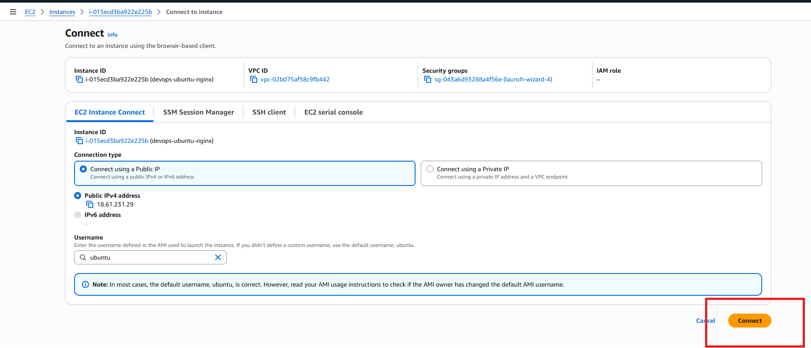

Step 2: Generate a New SSH Key Pair
On the Ubuntu EC2 instance, run:
ssh-keygen
Press Enter for all prompts:
Generating public/private rsa key pair.
Enter file in which to save the key (/home/ubuntu/.ssh/id_rsa):
Press Enter

Enter passphrase:
Press Enter

Enter same passphrase again:
Press Enter
This creates:
~/.ssh/id_rsa
~/.ssh/id_rsa.pub
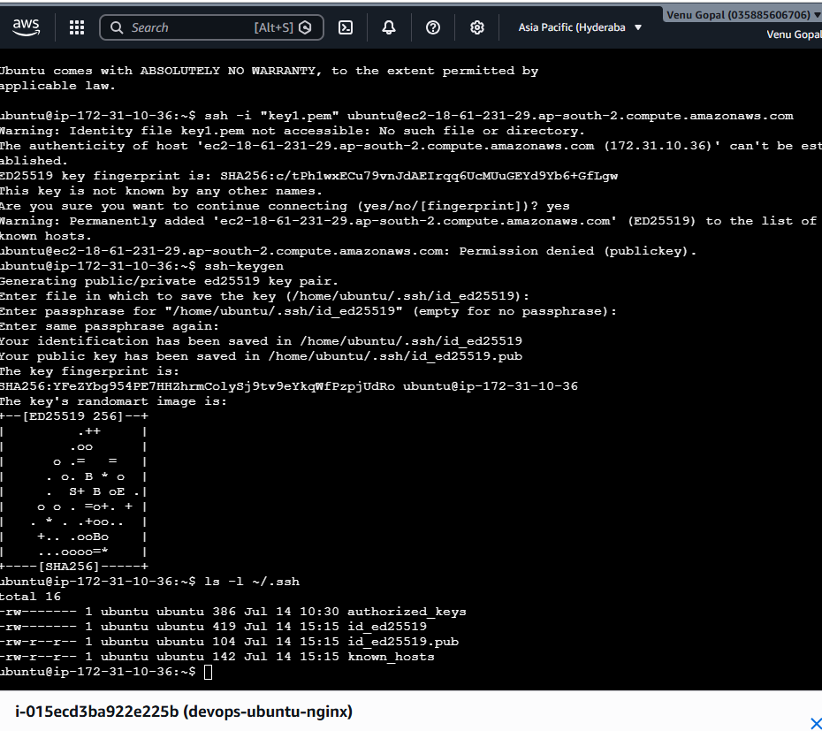

Step 3: Verify the Keys
Run:
ls -l ~/.ssh
You should see:
id_rsa
id_rsa.pub
authorized_keys

Step 4: Add the Public Key
Append the public key to the authorized keys file:
cat ~/.ssh/id_rsa.pub >> ~/.ssh/authorized_keys

Step 5: Set Permissions
Run:
chmod 700 ~/.ssh
chmod 600 ~/.ssh/authorized_keys
chmod 600 ~/.ssh/id_rsa

Step 6: Test Passwordless SSH
From the Ubuntu instance itself:
ssh localhost
The first time, type:
yes
You should log in without being asked for a password.
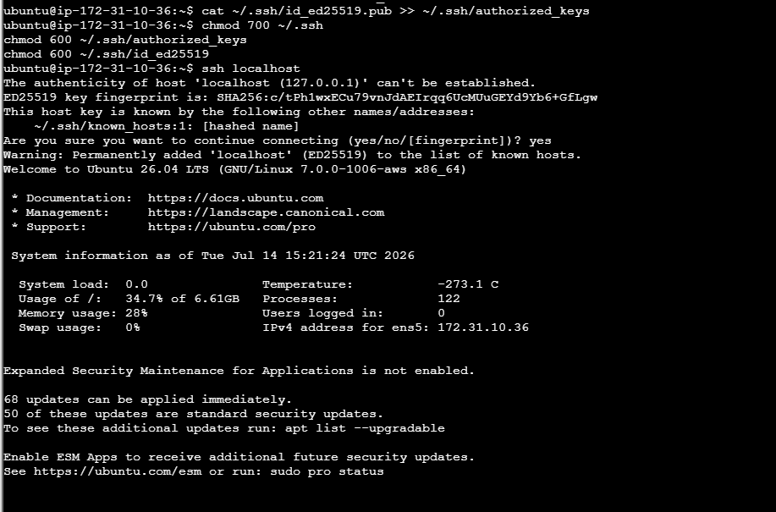

- Launch any EC2 using the spot purchasing option.
What is a Spot Instance?
A Spot Instance lets you use AWS's unused EC2 capacity at a discounted price. AWS can interrupt (stop or terminate) the instance if it needs the capacity back.

Step 1: Open EC2
- Log in to the AWS Management Console.
- Go to EC2.
- Click Launch Instance.

Step 2: Configure the Instance
Name
devops-spot-instance
AMI
Choose either:
- Amazon Linux 2023
- Ubuntu 24.04 LTS
Instance Type
t3.micro
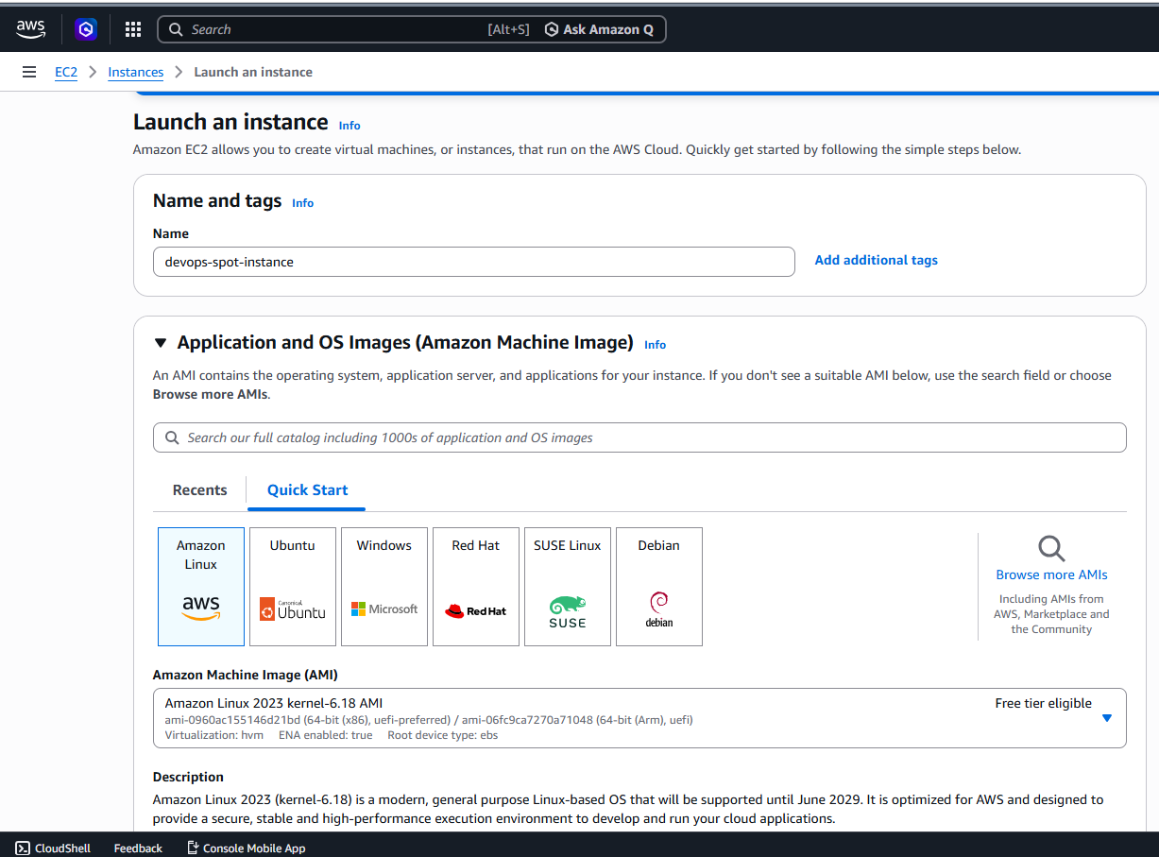
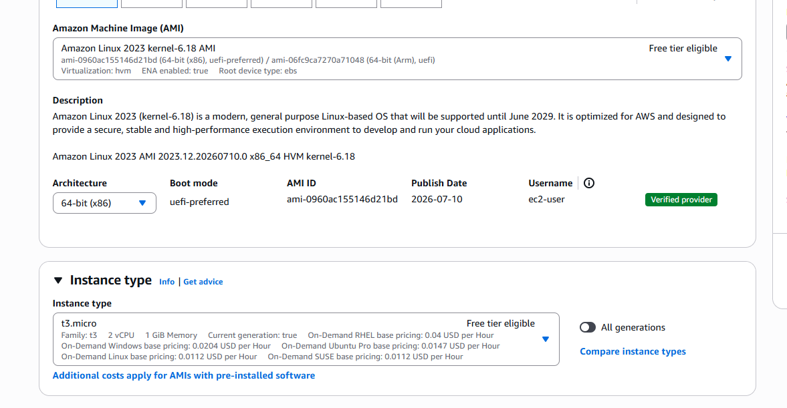

Step 3: Select Key Pair
Choose your existing key pair:
key1
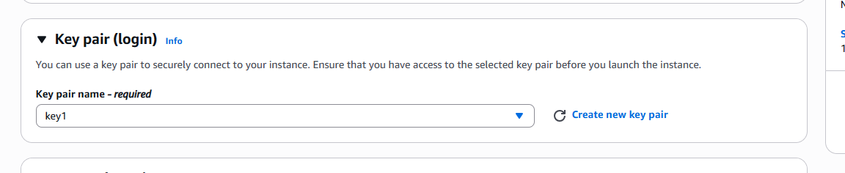

Step 4: Configure Security Group
Allow:
Type | Port | Source
SSH | 22 | My IP
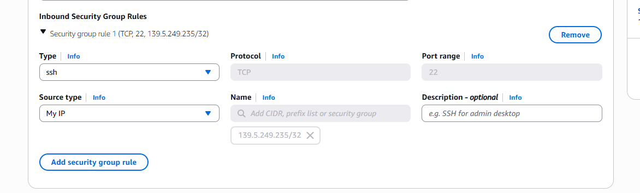
Step 5: Configure Spot Instance
Expand the Advanced details section.
Scroll to:
Purchasing option
Select:
Spot Instances
If prompted, leave the default Spot request settings.

Step 6: Launch the Instance
Click:
Launch Instance
If Spot capacity is available, AWS will launch the instance.

Step 7: Verify
Go to:
EC2 → Instances
You should see your new instance.
In the details, you should see:
Lifecycle: Spot
instead of:
Lifecycle: Normal
This confirms it's a Spot Instance.
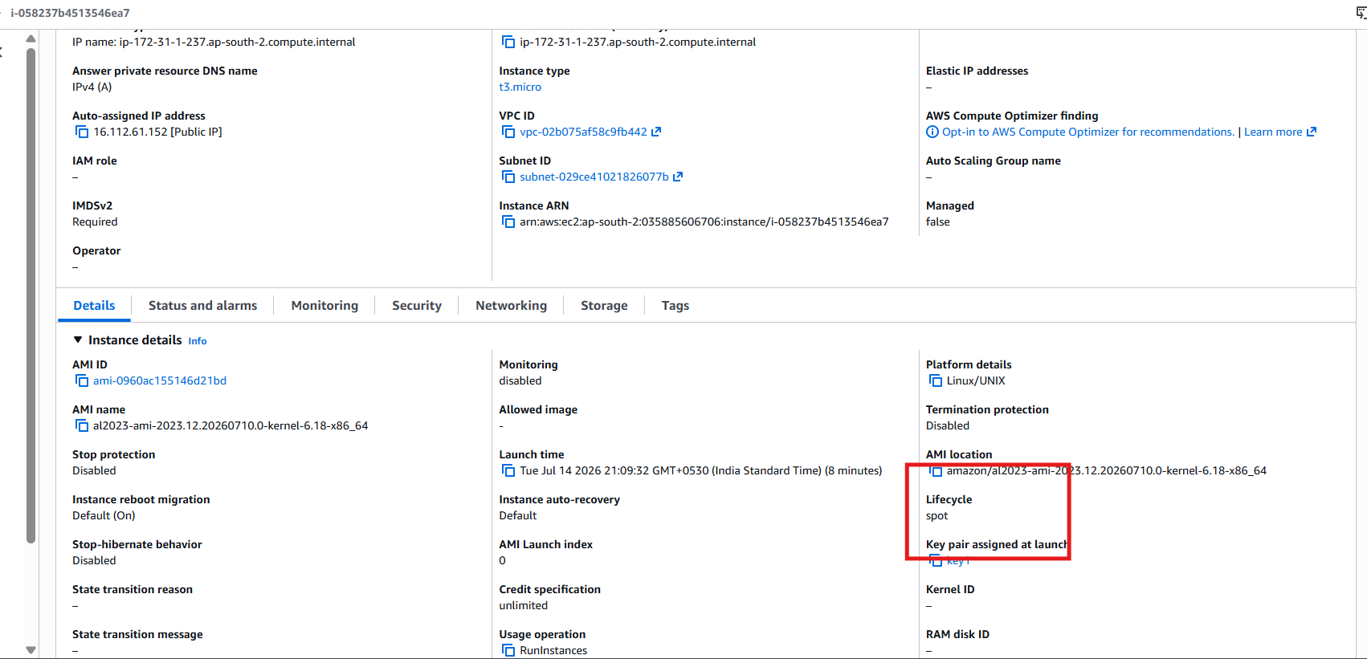

- Enable termination policy on the EC2 created in Task 2.

Step 1
Go to:
EC2 → Instances
Step 2
Select your Ubuntu EC2 instance (Task 2).
Step 3
Click:
Actions
↓
Instance settings
↓
Change termination protection
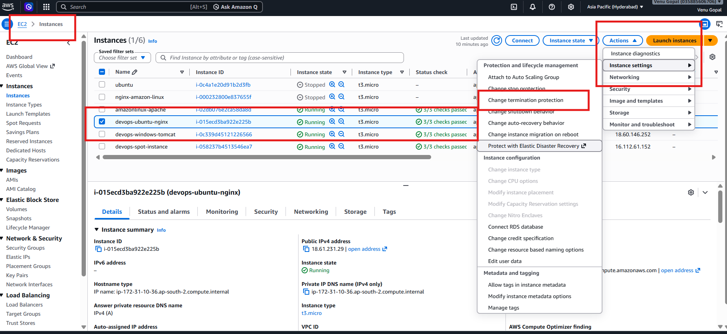

Step 4
Choose:
Enable
Step 5
Click:
Save
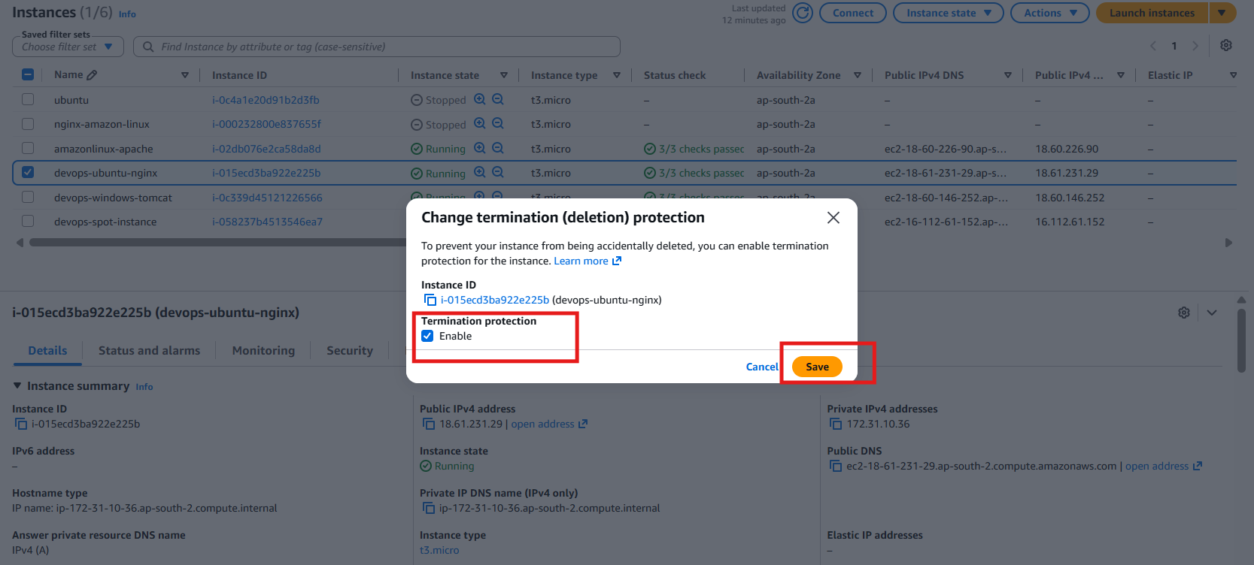

Verify
Go to:
EC2 → Instances
Select your Ubuntu instance.
Under Instance details, you should now see:
Termination protection: Enabled

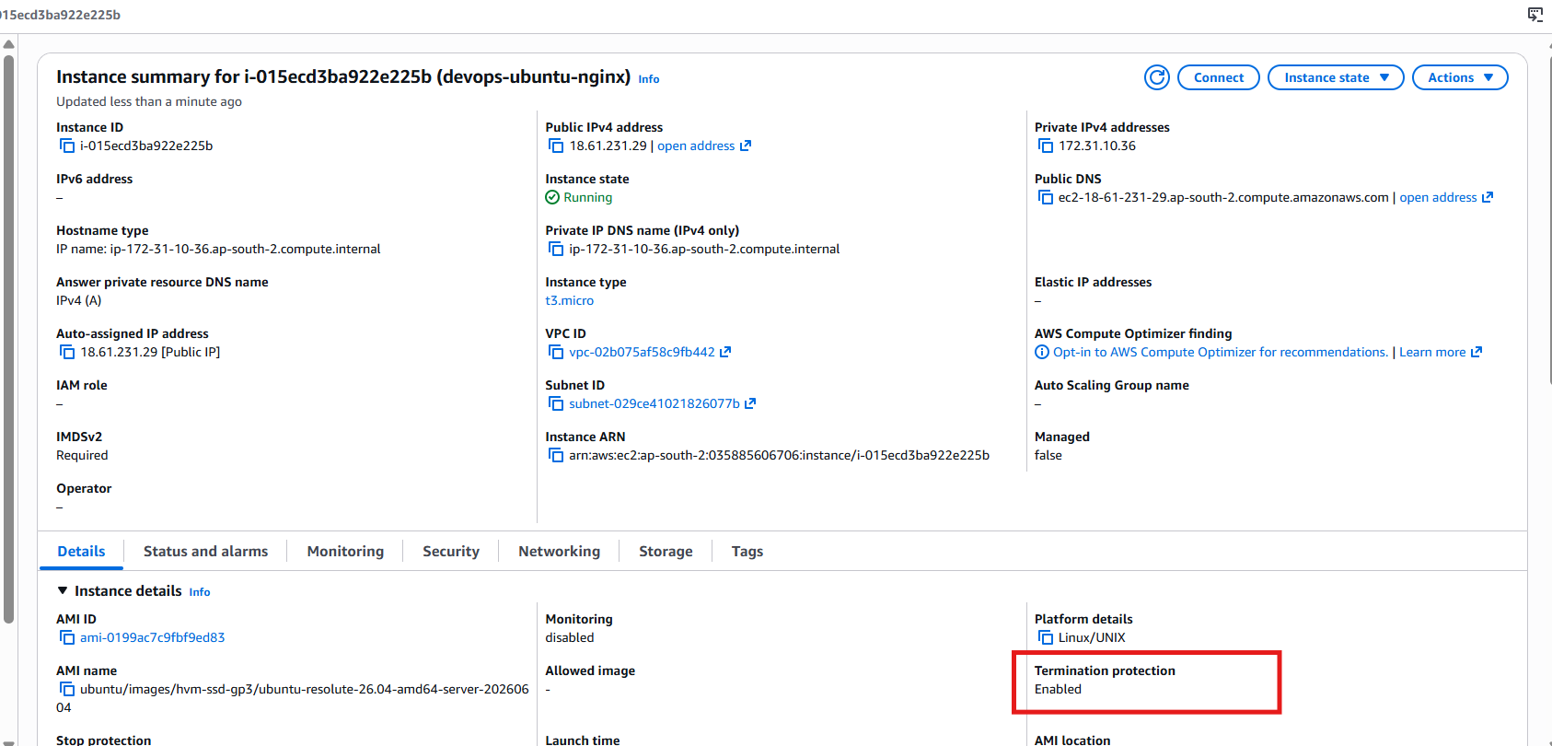
- Launch one EC2 using AWS CLI.

Objective
Launch an Amazon Linux 2023 EC2 instance using the AWS CLI.

Step 1: Open Git Bash
Open Git Bash on your Windows system.

Step 2: Verify AWS CLI Configuration
Run:
aws configure list
Expected output:
NAME : VALUE : TYPE : LOCATION
profile : <not set> : None : None
access_key : ****************XXXX : shared-credentials-file
secret_key : ****************XXXX : shared-credentials-file
region : ap-south-2 : config-file

Step 3: Verify Your AWS Account
Run:
aws sts get-caller-identity
Expected output:
{
"UserId": "AIDXXXXXXXXXXXX",
"Account": "123456789012",
"Arn": "arn:aws:iam::123456789012:user/your-user"
}
If this command works, your AWS CLI is ready.

Step 4: Get the Latest Amazon Linux 2023 AMI ID
Run:
aws ec2 describe-images \
--owners amazon \
--filters "Name=name,Values=al2023-ami-*" \
--query "sort_by(Images,&CreationDate)[-1].ImageId" \
--output text
From your output:
ami-0fbea88b076e96323

Step 5: Get the Security Group ID
Run:
aws ec2 describe-security-groups \
--query "SecurityGroups[*].[GroupName,GroupId]" \
--output table
From your output, use:
launch-wizard-5
sg-070dfa3bcad2adde6

Step 6: Get the Subnet ID
Run:
aws ec2 describe-subnets \
--query "Subnets[*].[SubnetId,AvailabilityZone]" \
--output table
From your output, we'll use:
subnet-029ce41021826077b

Step 7: Launch the EC2 Instance
Run this command exactly as shown:
aws ec2 run-instances \
--image-id ami-0fbea88b076e96323 \
--instance-type t3.micro \
--key-name key1 \
--security-group-ids sg-070dfa3bcad2adde6 \
--subnet-id subnet-029ce41021826077b \
--count 1 \
--tag-specifications 'ResourceType=instance,Tags=[{Key=Name,Value=cli-instance}]'
If successful, AWS returns JSON similar to:
{
"Instances": [
{
"InstanceId": "i-0abc123456789def0",
"State": {
"Name": "pending"
}
}
]
}

Step 8: Verify the Instance
Run:
aws ec2 describe-instances \
--filters "Name=tag:Name,Values=cli-instance" \
--query "Reservations[*].Instances[*].[InstanceId,State.Name,PublicIpAddress]" \
--output table
Expected output:
------------------------------------------------------
| DescribeInstances |
+----------------------+----------+------------------+
| i-0abc123456789def0 | running | 18.xx.xx.xx |
+----------------------+----------+------------------+

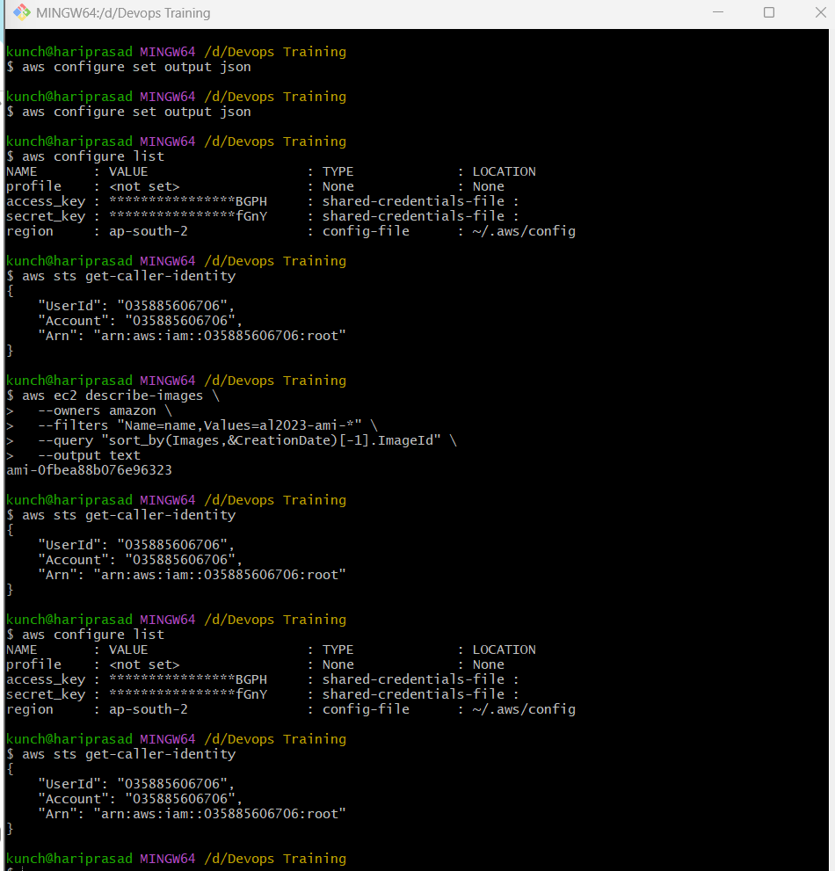

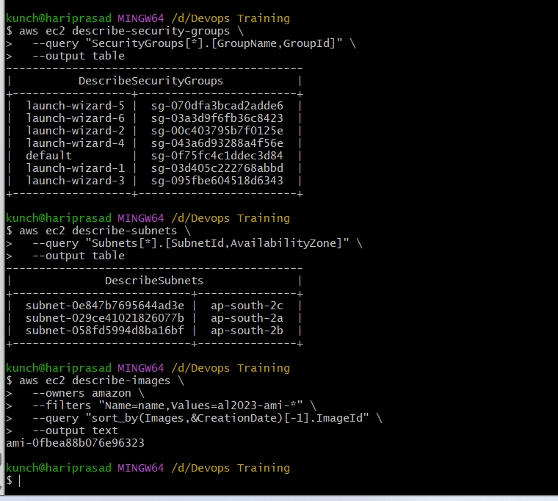

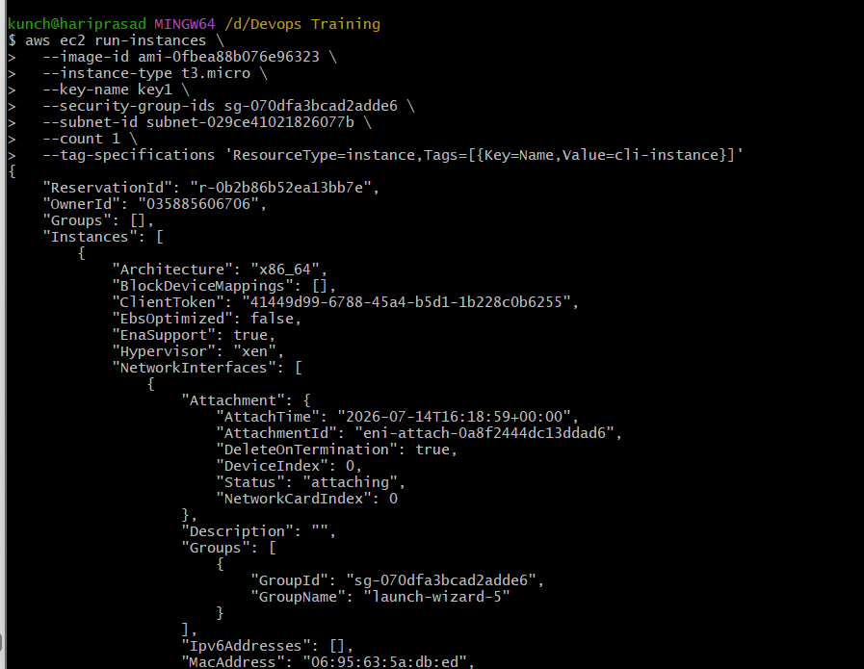
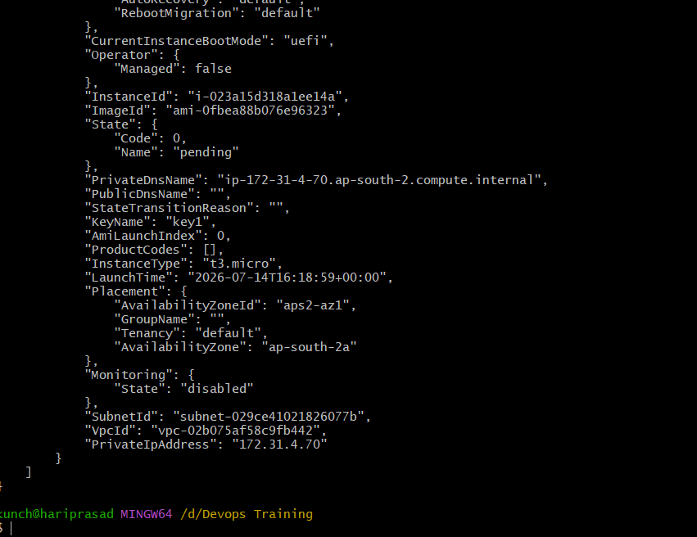

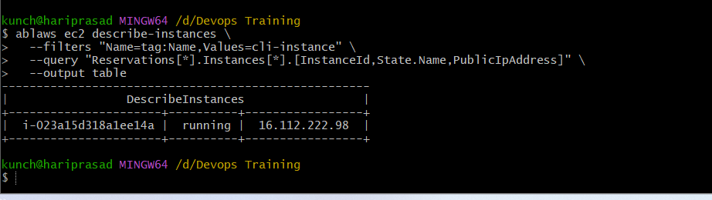
Step 9: Verify in the AWS Console
- Open AWS Console.
- Go to EC2 → Instances.
- You should see a new instance named:
cli-instance
Its state should be:
Running

